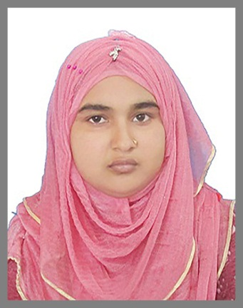RESUME OF

**MST. MOHANI AKTER**

Harivanga (Holditari), Sadar, Lalmonirhat.

Cell Phone- 01786280646, 01833673440

Email- mohiniaktermimisamiya@gmail.com

Github- https://github.com/mimisamiya

Up Work- https://www.upwork.com/freelancers/~0189000997c0326349

Linkedin- www.linkedin.com/in/mohiniaktermimi-samiya-a70a5734a



***CAREER OBJECTIVE***

To establish a challenging career through using my academic knowledge, analytical ability and personal creativity that will add desired value to your organization and ensure the organization long-term sustainability in the environment of frequent change and high competition side by side to gather practical experience working with the leading commercial bank of Bangladesh.



***ACADEMIC QUALIFICATIONS***

# Bachelor of Science (BSC)

* University : National University
* Subject : Botany
* Result : CGPA **3.12** (Out of **4.00**)
* Year of Passing : 2022

# Higher Secondary Certificate (HSC)

* Institution : Nageshwari Women’s College, Kurigram.
* Board : Dinajpur
* Group : Science
* Result : GPA **3.25** (Out of **5.00**)
* Year of Passing : 2018

# Secondary School Certificate (SSC)

* Institution : Kaliganj H.A High School, Kurigram
* Board : Dinajpur
* Group : Science
* Result : GPA **4.94** (Out of **5.00**)
* Year of Passing : 2015



***COMPUTER SKILL***

Working Operating System, Microsoft-Office, Adobe Photoshop, Internet Browsing, E-mail ,Typing skill in both Bangla and English, Also have sound knowledge in Computer networking with various operating system Capability on Hardware and Software Troubleshooting etc.



***EXPERIENCE***

* 2 Years working experience in Samiya Technology as a Computer Operator.



***LANGUAGE PROFICIENCY***

* Bengali (Mother Language).
* English (Speaking, Listening, Writing, and Reading ability)



***SELF ASSESSMENT***

* Good academic background and strong analytical ability.
* Capacity to manage increasing responsibility & diversity under time constraints.
* Confident enough to carry out duties with minimum instruction.
* Endurance to work for long hours and under pressure.
* Have skill in motivation and counseling and self-driven and change oriented.
* Sincere and eager to learn, willing to work in team.
* Familiarity with information & communication technologies.



***PERSONAL PROFILE***

* Name : Mst. Mohani Akter
* Father’s Name : Md. Mozammel Haque.
* Mother’s Name : Monowara Begum
* Date of Birth : 11-09-2000
* Blood Group : A(+) Positive
* Sex : Female
* Marital Status : Married
* National ID Number : 9165098717
* Nationality : Bangladeshi (By birth)
* Religion : Islam
* Height : 5 fit 1 inchs
* Weight : 59 Kg



***PERMANENT ADDRESS***

* Village : Harivanga (Holditari)
* Post Office : Lalmonirhat
* Post Code : 5500
* Upazila : Lalmonirhat Sadar
* District : Lalmonirhat



***REFERENCE***

**Md. Rezaul Karim Advocate Maruf Ahmmed**

Managing Director District and Sessions Judge`s Court

Samiya Technology Lalmonirhat.

College Bazar, Sadar, Lalmonirhat Mobile- 01729-565597

Mobile- 01780-562128

I understand declare that all the information given above is true. I am always ready to submit the necessary evidence or paper as required certifying those.

(Mst. Mohani Akter)